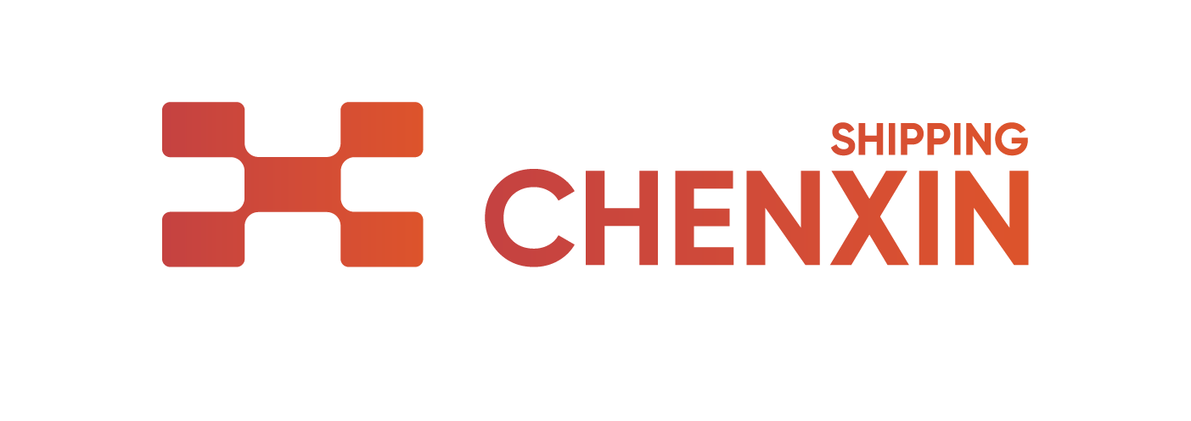

非危化工品订舱保函

To: CHENXIN COMPREHENSIVE SHIPPING Co., Ltd.
致：辰鑫综合航运有限公司

船名/航次(VSL/VOY) : __________________________
提单号(MLB No.) : _________________________________
起运港(Port of Loading) : _______________________
中转港(T/S PORT) : __________________________________
卸货港(Port of Discharge) : __________________________
目的港(Place of Delivery) : _______________________
目的地(Final Destination) : __________________________
CAS NO.: ____________________________________
箱量/型(Equipment volume/type) : ________________________________________________
中文品名(Commodity in Chinese) : ________________________________________________
英文品名(Commodity in English): _________________________________________________
包装单位(Package type)：
件数(Volume)：
重量(Weight): _________________________
产品外观与性状(Commodity shape and property): _____________________________________
离子性(Ionic): ______________________________________________

本产品主要用途(Utility of Goods):_______兹证明上述货物为一般化工品，非易燃，非易爆，非腐蚀，非有毒和有害的物质，非氧化剂，非麻醉品，非精神性药品，无放射性，非用于制造化学武器的原料，在航海运输中属于非危险品，适合航海运输。如在航海运输过程中由此而产生的一切后果、责任、风险，均由我司承担。
我司特此证明上述产品为一般化工品，不属于《国际海运危险货物规则》一书中所列的危险品。其包装及装载均符合海上运输要求。如以上陈述不实而引起在运输途中发生任何问题，承运人有权按照《中华人民共和国海商法》第六十八条规定在任何时间、任何地点根据情况需要将货物卸下、销毁或者使之不能为害，而不负赔偿责任。我司对承运人因运输此类货物所受到的损害，应当负赔偿责任。承运人将保留依照有关法律及港监有关规定向我司追究法律责任的权利。由此产生任何责任、风险与相关费用由我司承担！
We hereby confirm above goods belongs to common chemical product which is not in the dangerous cargo list of <<International Maritime Dangerous Goods Code >> cargo package and loading strictly in conformity with the regulations governing the maritime transportation of such goods.
In case of any an actual danger to the ship, the crew and other persons on board or to other goods as consequence of failure to declare above inaccurately, according to Article 68 of << MARITIME CODE OF THE PEOPLE’S REPULIC OF CHINA>>, the carrier may have such goods landed, destroyed or rendered innocuous when and where circumstances so require, without compensation. The undersigned shall be liable to the carrier for any loss, damage or expense resulting from such shipment. Carrier will also hold the right for any legal action against relative laws or regulations. The undersigned will be liable for all the responsibility and cost that may cause.

盖订舱代理公司的正本、圆形、中英文对照公章 盖发货人的正本、圆形、中英文对照公章

__________________________________________ _________________________________________

日期： 年 月 日
（以上所有填写内容手写无效）

*我们（即保函下签章的公司）确认，本担保函的电子版本与其原件具有相同的法律效力。

